Flash, Crash, Rumble, Roll

Name________________________

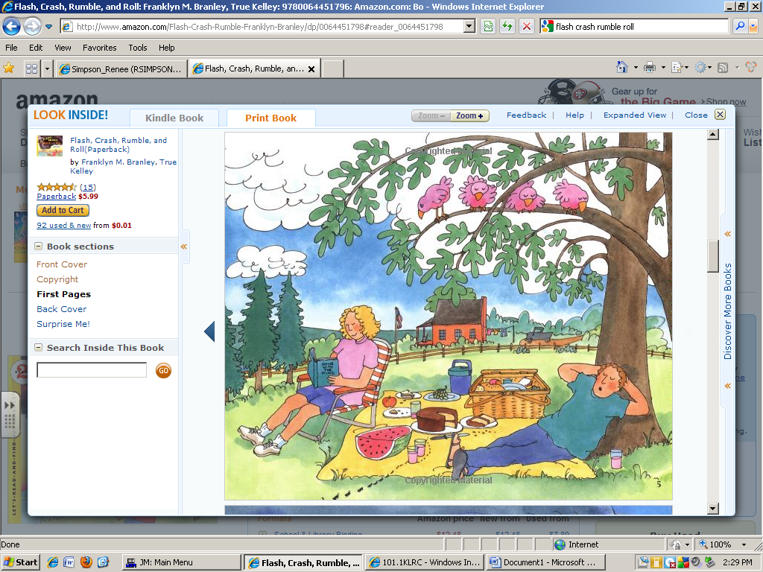

The people are having a ______________.

picnic party puppy

Birds are ____________ in the trees.

flying singing sleeping

The man is __________ on the tree.

standing resting climbing

The man and woman might be on…

the phone vacation airplanes the beach